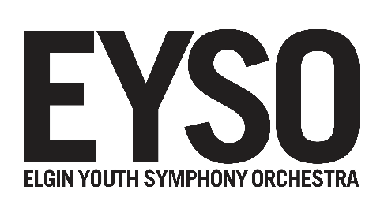
EYSO AT-A-GLANCE

- Founded in 1976, EYSO is one of the oldest and largest youth orchestras in Illinois, comprising five orchestras, a brass choir, two percussion ensembles, a thriving Chamber Music Institute, and four honors chamber ensembles.

- EYSO serves 400 students, grade 4 – college, from more than 70 Chicagoland communities.

- Twice named “Youth Orchestra of the Year” by the Illinois Council of Orchestras (ICO) EYSO in 2005 and 2015 received their “Programming of the Year” award—an unusual distinction for a youth orchestra. In 2008, ICO recognized Artistic Director Randal Swiggum as “Conductor of the Year.”

- More than 6,000 people attend EYSO’s season concerts annually at Elgin Community College Arts Center’s Blizzard Theatre and Spartan Auditorium. Through touring performances, festival appearances, radio broadcasts, collaborations with other local performing arts groups, and community outreach performances—including programs in area schools and retirement centers, free open rehearsals, and charitable events—EYSO shares the enrichment of classical music with up to 60,000 additional children, adults, and seniors each year.

- In our 40th Anniversary Season (2015-16) EYSO ensembles performed alongside such distinguished artists as Rachel Barton Pine, Grammy-winning chamber ensemble Eighth Blackbird and, were conducted by Daniel Boico. Previous guest coaches and collaborators include: Yo-Yo Ma; Midori; the Silk Road Ensemble; Fulcrum Point New Music Project; the former touring cast of the hit musical Jersey Boys; Elgin Symphony Orchestra; Elgin Master Chorale; and Ballet Folklorico Huehuecoyotl.

- EYSO students enjoy ongoing opportunities to hone skills with world-class guest coaches including: Daniel Boico; violin virtuoso Midori; Ted Atkatz, former principal percussionist for the Chicago Symphony Orchestra; CSO trumpeter Will Scarlett; violinist Rachel Barton Pine; violinst Elena Urioste; pianist Joyce Yang; cellist Matt Haimovitz; violinist, Michael Ludwig; Brandon Ridenour, trumpeter; Carter Brey, cellist; Philippe Quint , violinist and Michael Sweeney, bassoonist. In 2017, violinist Angelo Xiang Yu, and clarinetist Alexander Fiterstein, will conduct masterclasses with EYSO students.

- In addition to presenting masterworks of classical repertory, EYSO has commissioned and premiered more than 20 works by local, regional, and national composers, including Daniel Brewbaker, Robert Hanson, and John Stevens. In 2016, EYSO added Ethan T. Parcell as composer in residence.

- In 2004, EYSO was the first youth orchestra to perform at the Ravinia Festival, most recently performing Mozart’s Magnificent Voyage in 2014. In 2006 the Youth Symphony was featured at the Aberdeen International Youth Arts Festival in Scotland.

- In 2008, EYSO and Elgin Symphony Orchestra were awarded a prestigious joint Orchestra Residency with violin virtuoso Midori, one of only two such residencies granted by the artist each year.

- In 2009, EYSO performed at the state capitol in Springfield, Illinois, as part of the commemoration of the Lincoln Bicentennial. In 2012, EYSO toured the southern United States on their Civil War Tour.

- EYSO Honors Chamber Ensembles have been featured on NPR’s acclaimed music program From the Top and as well as on WFMT-FM’s Introductions program, aired nationwide via radio and Internet.

- EYSO strives to make participation accessible to any qualified student and provides tuition assistance to families with financial need. Some 35% of EYSO members currently receive some form assistance.

For more information, visit EYSO.org

